Exam level B 1 : speaking (Cambridge's PET)

PET part 1 : General introduction
In Part 1 the examiner will ask you questions. These could be about home, work, where you live, what you do, your family, etc. The examiner will ask you in turn. You must listen while the other student answers the question.

PET part 2 : Conversation
In Part 2 you have to listen while the teacher explains a situation. Then the teacher will give you a picture and repeats the situation. You have to discuss the situation with your partner. Here are some examples: learning something new, visiting someone in hospital, a present from Paris, the Graduation present, getting around Europe,...
Expressions to help you to
1/ make a suggestion : | - Why don’t we + BV ?  - What do you think of + Bving / noun?  - How about … / What about / … + Bving / noun
2/ agree | - I agree with you because ….  - Yes, you're right, because …. / That's true, because …. / That’s a good idea, because ….
3/ disagree | - I'm afraid I don't agree with you because …  - Hmm, I don’t think so, because…  - I see what you mean, but …  - That's a good point, but on the other hand ….
4/ conclude | - OK, let's make a decision  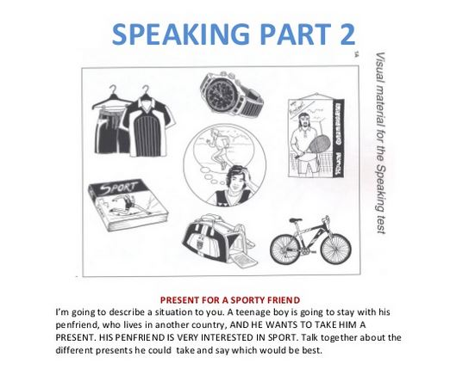  - Shall we come to an agreement ?

EXAMPLES

Situation 1 :

-------------------------------------------------------------------------------------------------------------------------------------------
Situation 2 : Your friend has just passed his driving test and you would like to buy a present for him. Talk together about the sort of presents you can buy and decide which one to get for him.

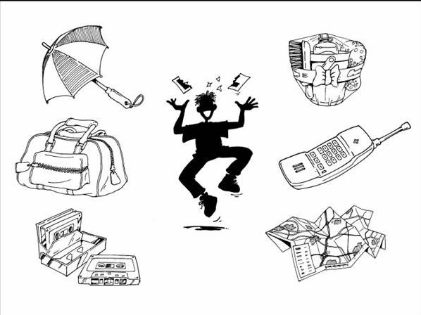

-------------------------------------------------------------------------------------------------------------------------------------------
Situation 3 : A group of friends wants to spend the day travelling round a big city but they don't have much money. They want to see as many things as possible. Talk together about the different ways they could travel round the city and decide which way would be best.
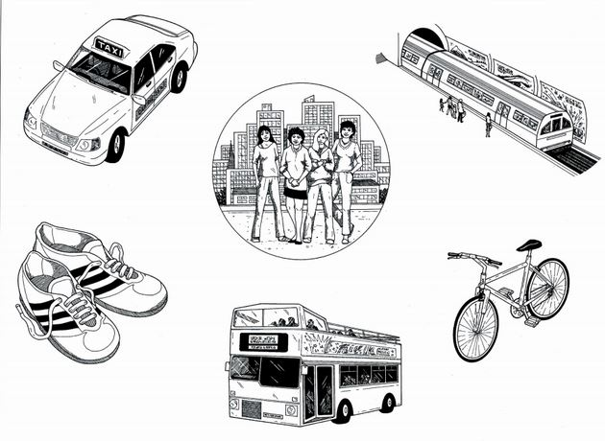

PET Part 3 : Describe an image

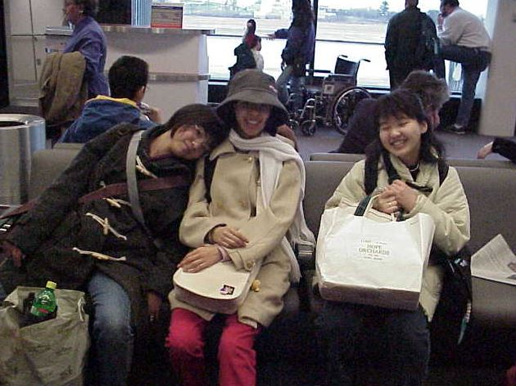
In Part 3, you have to talk for one minute about a picture. After you finish, your partner will talk for one minute about another picture. Below are examples of pictures.

ALWAYS USE be +ing to describe actions on a pic !

The picture shows three girls waiting for a plane in the
departure lounge at an airport.
They are laughing and having a lot of fun, even though
I think they have been waiting a long time. I think
they’ve been waiting a long time because they look tired
especially the girl on the left. She is leaning her head
on her friend’s shoulder. The girl on the right has
finished reading a paper, and it looks like they have
been drinking some Seven-Up while they were waiting.
As well as that, the airport is crowded, and there are a
lot of other people waiting for the next plane. They all have some hand luggage, but I can’t see any big bags, so they must have checked in their baggage already. They are wearing coats and hats and scarves, so the weather must be cold at the airport or where they are going.
--------------------------------------------------------------------------------------------------------------------------------------------
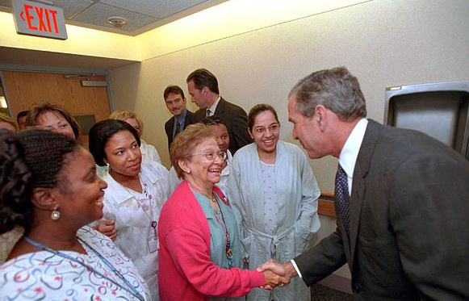
The picture shows a man, I think it is George Bush,
visiting a hospital. There are a lot of people in the
picture. Most of them are hospital workers, but some
could be patients. Some of them are doctors and
nurses, because they are wearing uniforms and have
ID cards. One of the staff is shaking hands with
George Bush and she is laughing. Maybe he is saying
something funny because a lot of the people are
laughing or they are smiling. In the background, there
are some men. They could be hospital administrators,
but maybe they are policemen or security.

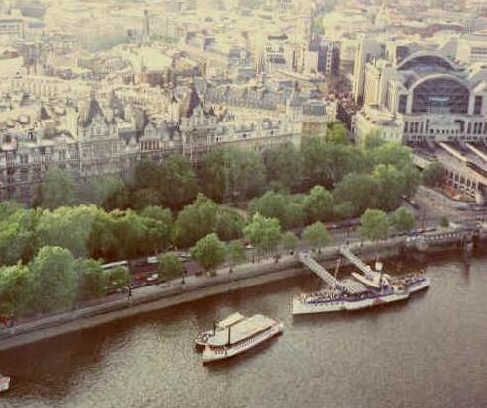
This is a picture of a big city on a river. The picture
was taken from high up, maybe from a skyscraper or
a tower or maybe even an airplane. The picture shows
boats and ships in the river and some big old and
modern buildings on the land. There are trees along
the river and there is some traffic on the road. One of
the ships looks old, and there are some steps so that
people can walk onto it. Maybe it is a cruise ship for
tourists. In the right of the picture there is a big modern
building. I think it is a museum or a train station or
a big shopping center.

Pet Part 4 : discussion

In Part 4, you have to talk with your partner about a topic. The topic will be related to the photos you saw in Part 3.
For example, if the two photos were about games, then you will have to talk together about games you play or like, or games you used to play. If the two photos in Part 3 showed old people, Part 4 might be about old people in your country, or an old person you know.

…. Pour plus d'entraînement au PET (test de niveau B1) voir, entre autres :
http://writefix.com/?page_id=359
www.missbeez.blog4ever.com

